* **Practical -2**

**NAME : JAYMIN VALAKI ROLLNO: MA067 MOBILE APPLICATION DEVELOPMENT**

**Running Java code on android studio and Demonstrating Activity Lifecycle**

**1. Write down steps to run java program in android studio**

* From the project folder select java folder
* Right click on java folder and select new then java class.
* Provide a class name and press ok.
* Right the java code.
* Right click on java file and select run “Print. Main()” with coverage**.**

**2.** **Write a java program to print 1 to 10 using for loop.**

**Program1.java**

package com.example.firstapp;

public class program1 {

public static void main(String[] args) {

for (int i = 1; i <= 10; ++i) {

System.out.println(i);

}

}

}

**Output**:

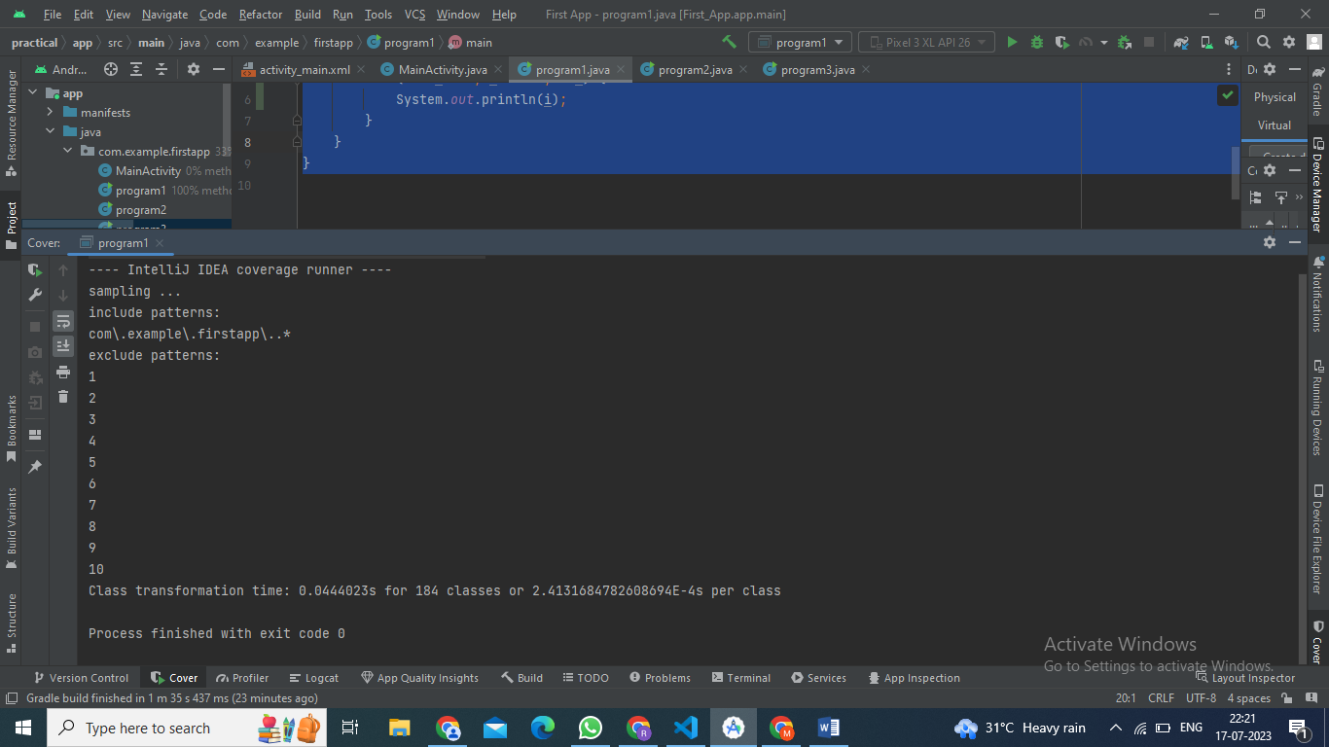

**3. Write a java program to check whether the entered number is odd or even.**

**Program2.java**

package com.example.firstapp;  
  
public class program2 {  
 public static void main(String[] args) {  
 int num = 5;  
 if (num % 2 == 0)  
 System.*out*.println("Entered number is even");  
 else  
 System.*out*.println("Entered number is odd");  
 }  
}

**Output**:

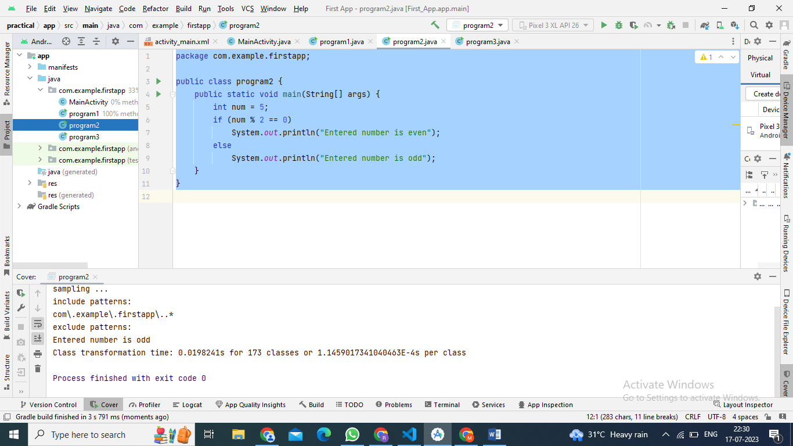

**4. Write a java program to check whether the entered number is prime or not.**

**Program3.java**

package com.example.firstapp;  
public class program3 {  
 public static void main(String[] args) {  
 int num = 29;  
 boolean isprimenum = true;  
 for (int i = 2; i <= num / 2; ++i) {  
 if (num % i == 0) {  
 isprimenum = false;  
 break;  
 }  
 }  
 if (isprimenum)   
 System.*out*.println(num + " is a prime number.");  
 else   
 System.*out*.println(num + " is not a prime number.");  
 }  
}

**Output:**

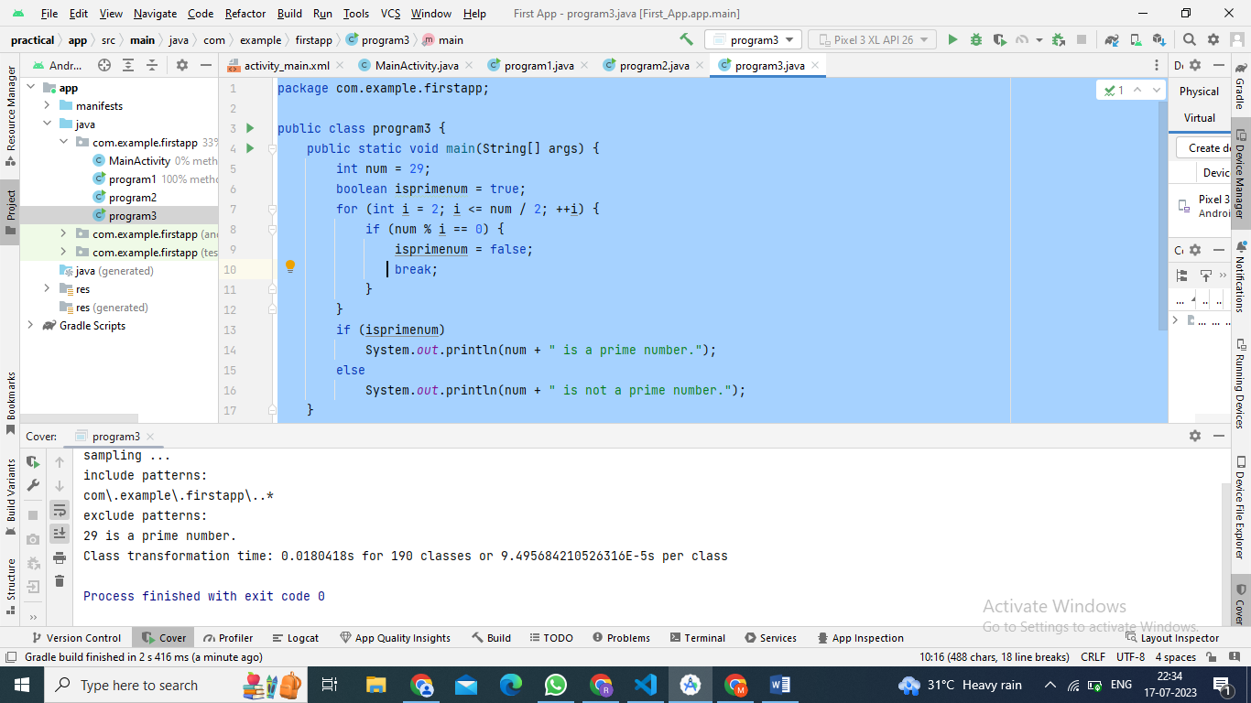

**5. Write a Java Program to Find Square Root of a Number Without sqrt Method.**

**Program4.java**

package com.example.firstapp;  
  
public class program4 {  
 public static void main(String[] args) {  
 int number = 64;  
 double temp;  
  
 double squareRoot = number / 2;  
  
 do {  
 temp = squareRoot;  
 squareRoot = (temp + (number / temp)) / 2;  
 } while ((temp - squareRoot) != 0);  
  
 System.*out*.println("Square Root of "+ number+ " is: "+squareRoot);  
 }  
}

**Output:**

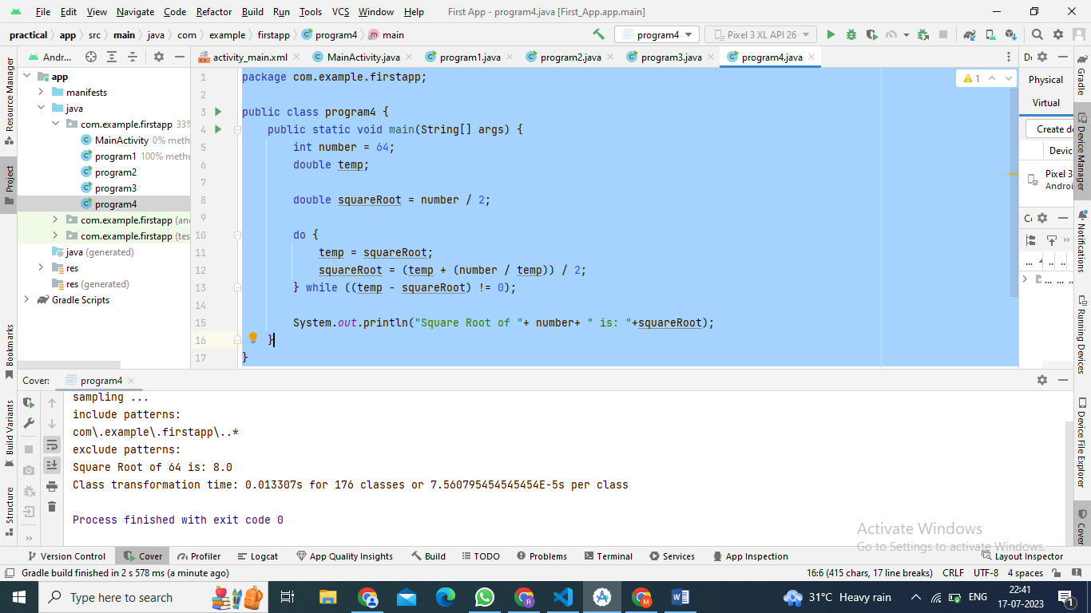

**6. Write a Java Program to Display Even Numbers From 1 to 100.**

**Program5.java**

package com.example.firstapp;  
public class program5 {  
 public static void main(String[] args) {  
 int limit = 100;  
 System.*out*.println("Printing Even numbers between 1 and " + limit);  
 for(int i=1; i <= limit; i++){  
 if( i % 2 == 0){  
 System.*out*.print(i + " ");  
 }  
 }  
 System.*out*.println();  
 }  
}

**Output:**

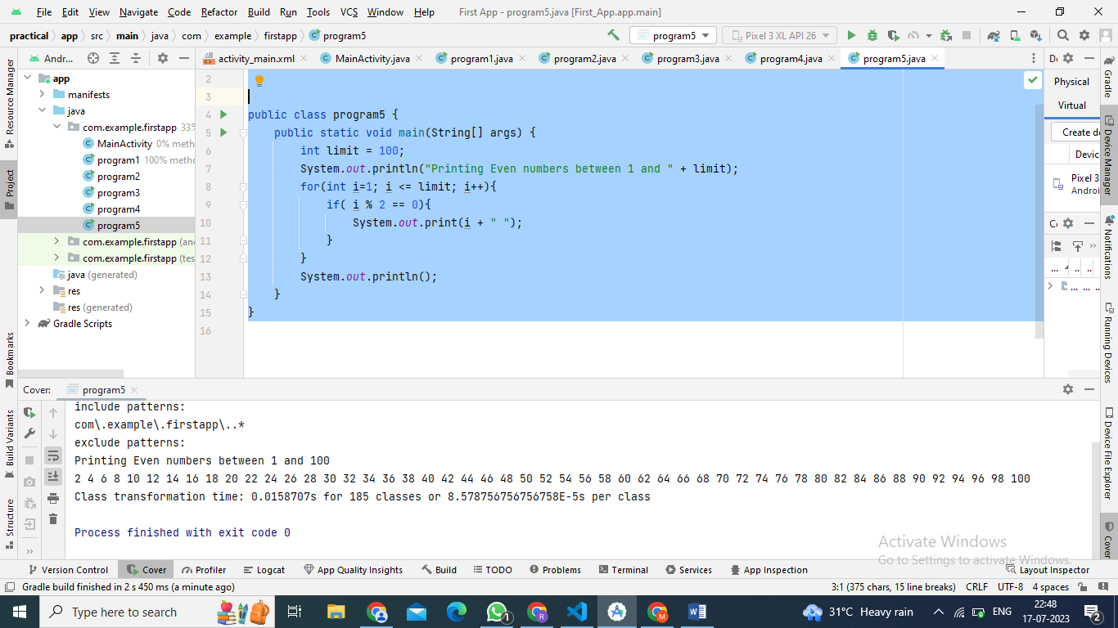

**7. Write a Java Program to Display Alternate Prime Numbers.**

**Program6.java**

package com.example.firstapp;  
public class program6 {  
 public static boolean isPrime(int number) {  
 if (number <= 1) {  
 return false;  
 }  
 for (int i = 2; i <= Math.*sqrt*(number); i++) {  
 if (number % i == 0) {  
 return false;  
 }  
 }  
 return true;  
 }  
 public static void main(String[] args) {  
 System.*out*.println("Alternate Prime Numbers:");  
 int count = 0;  
 for (int i = 1; i <= 50; i++) {  
 if (*isPrime*(i) && count % 2 == 0) {  
 System.*out*.print(i + " ");  
 }  
 if (*isPrime*(i)) {  
 count++;  
 }}  
 System.*out*.println();

}  
}

**Output:**

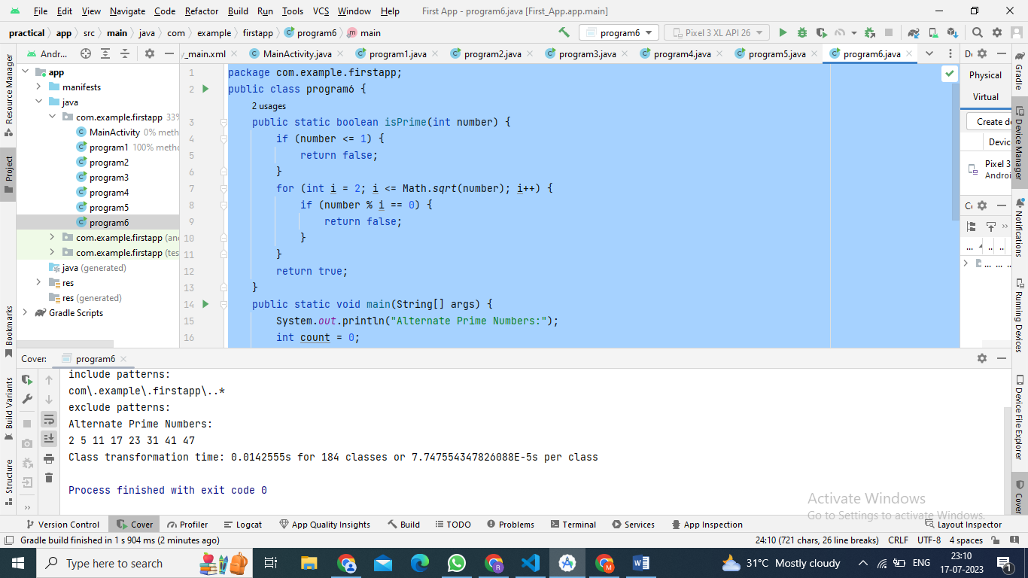

**8. Write a Java Program to Reverse a Number.**

**Program7.java**

package com.example.firstapp;  
  
public class program7 {  
 public static void main(String[] args) {  
 int num = 1234, reversed = 0;  
 while(num != 0) {  
 int digit = num % 10;  
 reversed = reversed * 10 + digit;  
 num /= 10;  
 }  
 System.*out*.println("Reversed Number: " + reversed);  
 }  
}

**Output:**

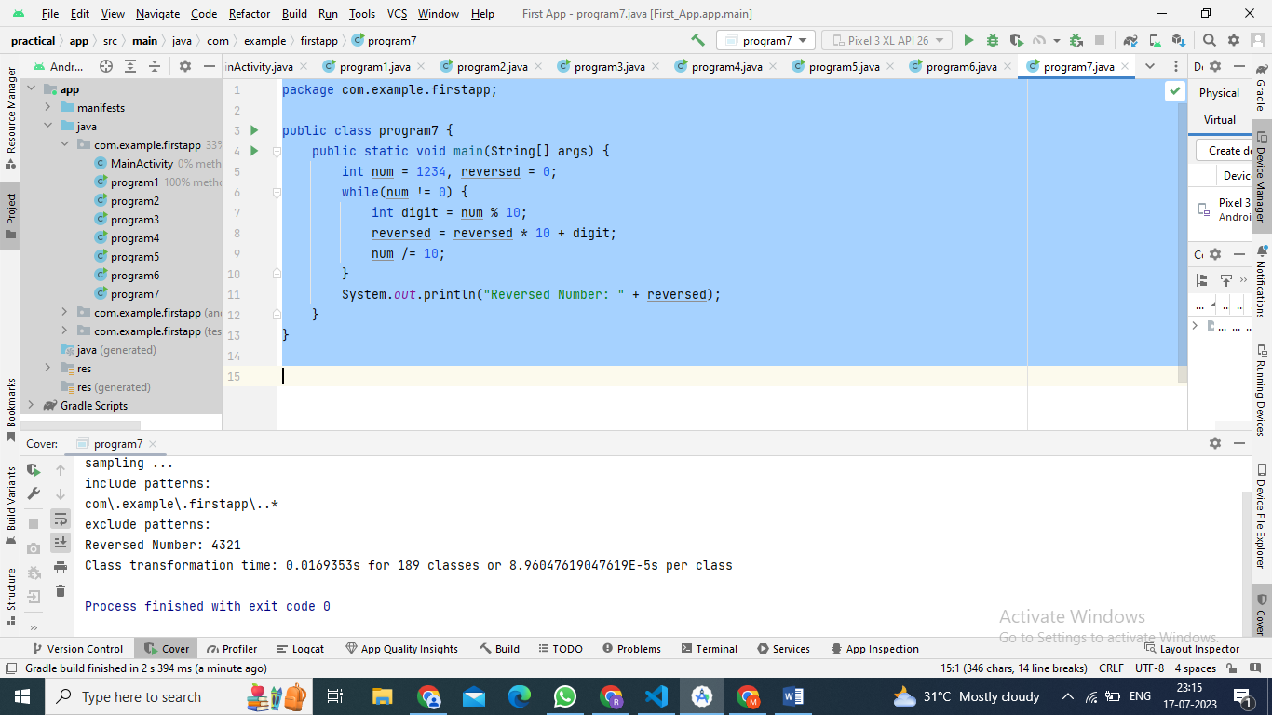

**9. Write a Java Program to check whether the entered number is a Peterson Number or not.**

**Program8.java**

package com.example.firstapp;  
  
public class program8 {  
 public static void main(String[] args) {  
 int num = 145;  
 int sum = 0;  
 int temp = num;  
 while (temp > 0) {  
 int rem = temp % 10;  
 int fact = 1;  
 for (int i = 1; i <= rem; i++) {  
 fact = fact * i;  
 }  
 sum = sum + fact;  
 temp = temp / 10;  
 }  
 if (sum == num) {  
 System.*out*.println("It is a Peterson Number");  
 } else {  
 System.*out*.println("It is not a Peterson Number");  
 }  
 }  
}

**Output:**

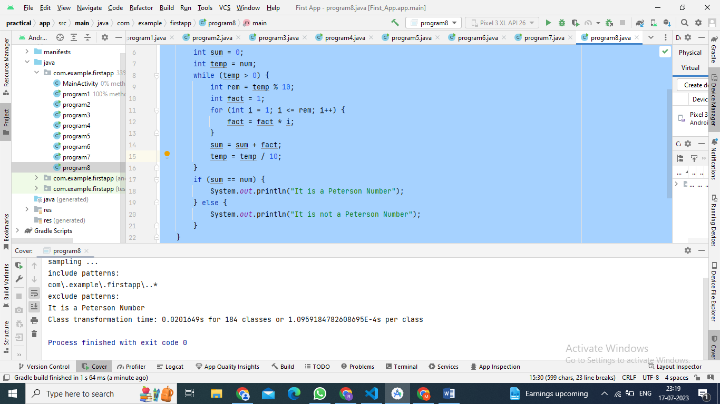

**10. Write a Java Program to check whether the entered number is a Tech Number or not.**

package com.example.firstapp;  
  
public class program9 {  
 public static void main(String[] args) {  
 int num = 10;  
 int sum = 0;  
 int prod = 1;  
 int temp = num;  
 while (num > 0) {  
 int rem = num % 10;  
 sum = sum + rem;  
 prod = prod * rem;  
 num = num / 10;  
 }  
 if (sum == prod) {  
 System.*out*.println(temp + " is a tech number");  
 } else {  
 System.*out*.println(temp + " is not a tech number");  
 }  
 }  
}

**Output:**

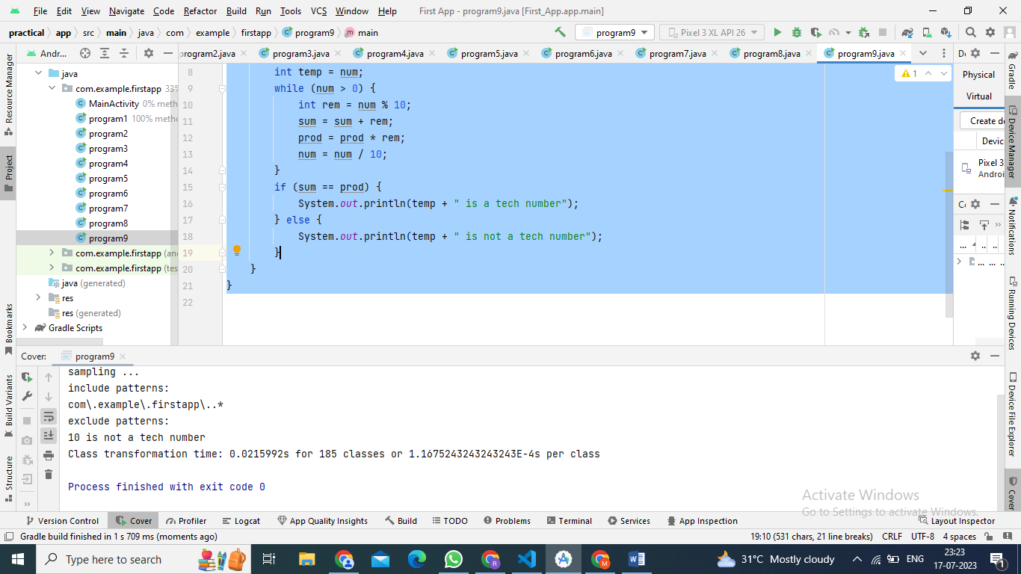

**Demonstrating Activity Life Cycle**

**MainActivity.java**

package com.example.firstapp;  
import android.util.Log;  
import androidx.appcompat.app.AppCompatActivity;  
import android.os.Bundle;  
public class MainActivity extends AppCompatActivity {  
 @Override  
 protected void onCreate(Bundle savedInstanceState) {  
 super.onCreate(savedInstanceState);  
 setContentView(R.layout.*activity_main*);  
 Log.*d*("lifecycle","onCreate invoked");  
 }  
 @Override  
 protected void onStart() {  
 super.onStart();  
 Log.*d*("lifecycle","onStart invoked");  
 }  
 @Override  
 protected void onResume() {  
 super.onResume();  
 Log.*d*("lifecycle","onResume invoked");  
 }  
 @Override  
 protected void onPause() {  
 super.onPause();  
 Log.*d*("lifecycle","onPause invoked");  
 }  
 @Override  
 protected void onStop() {  
 super.onStop();  
 Log.*d*("lifecycle","onStop invoked");  
 }  
 @Override  
 protected void onRestart() {  
 super.onRestart();  
 Log.*d*("lifecycle","onRestart invoked");  
 }  
 @Override  
 protected void onDestroy() {  
 super.onDestroy();  
 Log.*d*("lifecycle","onDestroy invoked");  
 }  
}

**Output:**

**Now you can see on the logcat:**

**on Create, on Start and on Resume methods are invoked.**

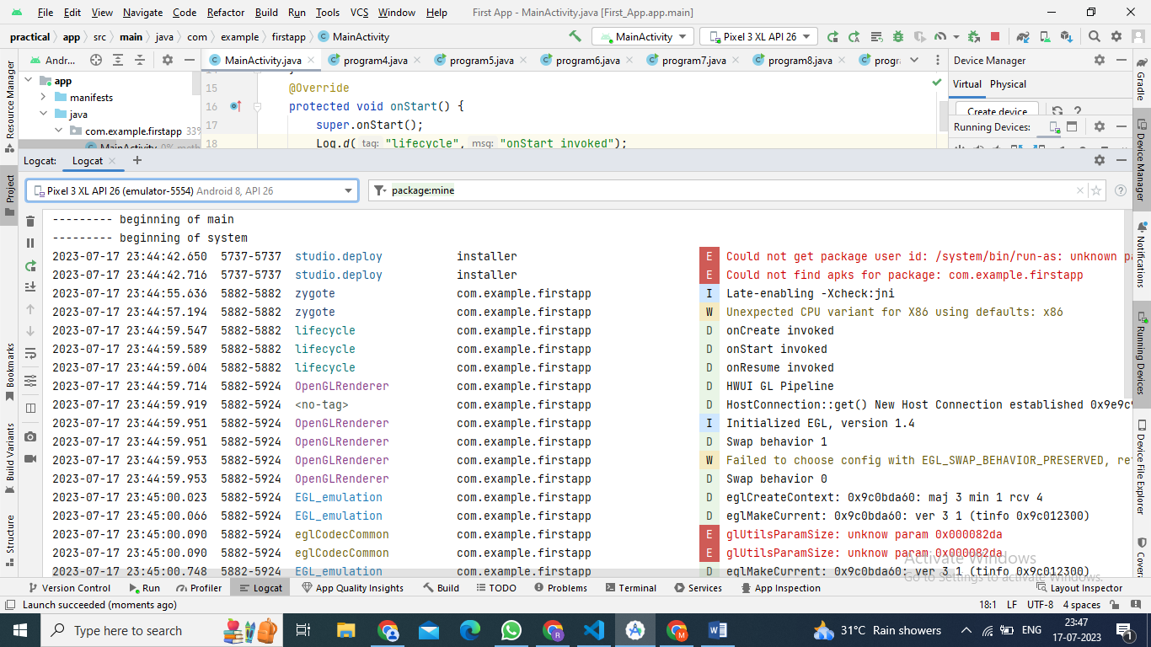

Now click on the HOME Button. You will see onPause method is invoked. After a while, you will see onStop method is invoked. 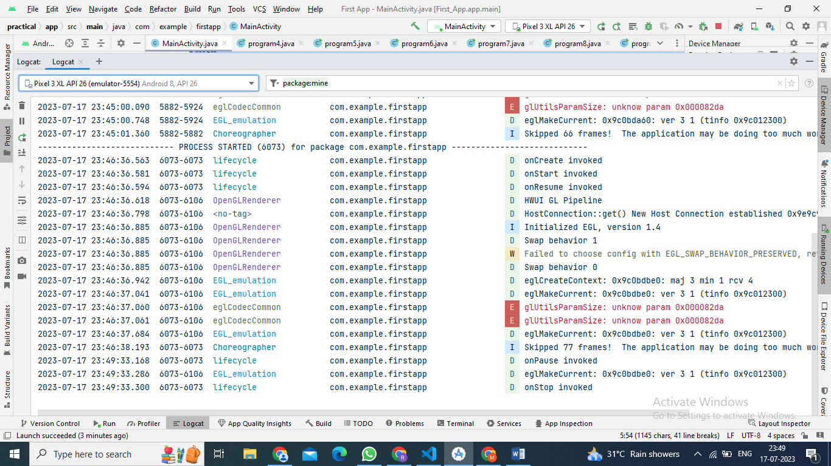

Now see on the emulator. It is on the home. Now click on the Center button to launch the app again.

